Cultural Adventures:
Tours for the Young-at-Heart
Cultural Galapagos Escorted Trip
March 10 - 19, 2016

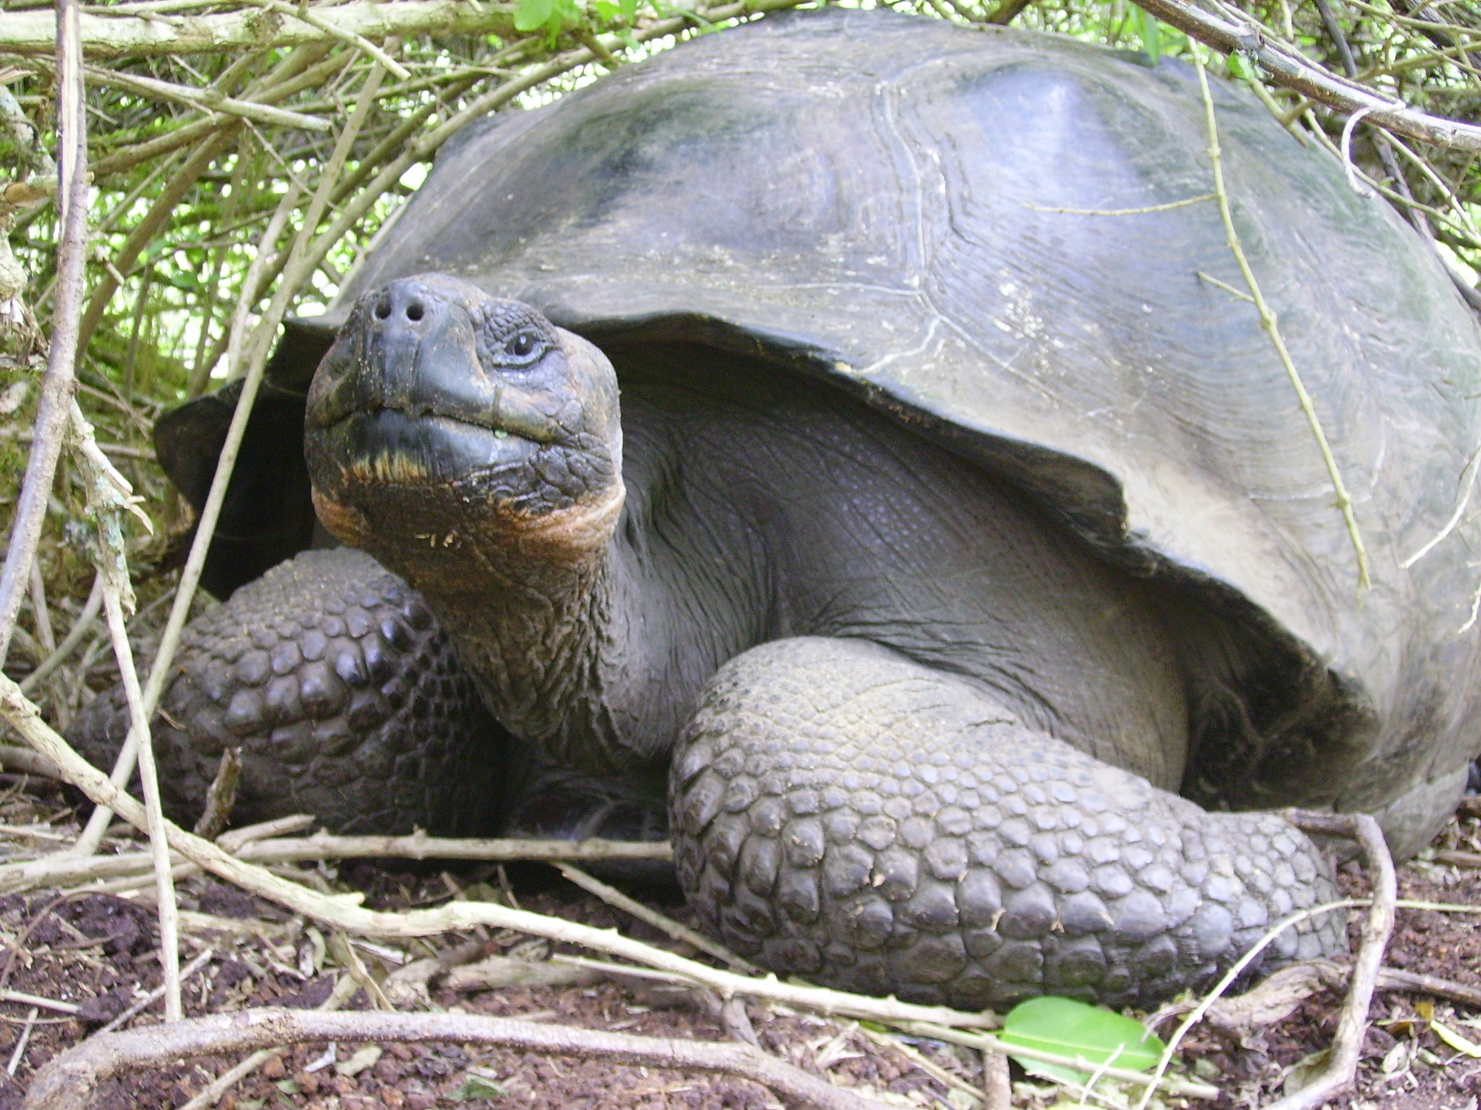

Cultural Adventures tours offer you the opportunity to learn about a fascinating culture as part of a small group. You’ll enjoy select experiences away from the usual tourist sights during a visit that combines soft adventure with maximum comfort. The tour is land-based providing a comfortable hotel each evening after a day of exploring the islands, viewing the incredible animals and birds, and sailing, snorkeling and swimming. When you take a Cultural Adventures trip, you are supporting local farmers and fishermen, along with other local people who provide information and services.

Trip Fee: $3395 per double occupancy; Single supplement $330;
Receive a $100 discount if balance is paid by December 1, 2015.
Included: All hotels, flight from mainland Ecuador to the Galapagos, land and sea transportation, tours, snorkeling and kayaking equipment, airport transfers, guides, escort and 21 meals
Not included: International flight to Ecuador, the $120 Galapagos Park fee
- Proximity to exotic wildlife---sea lions, iguanas, giant tortoises, boobies, and more
- Combine guided tours with opportunities to explore on your own
- Guaranteed group size of 6 to 12
- Travel with an escort who will provide valuable information and travel tips before and during the trip

Itinerary:
Day One, Mar 10 – Arrive in Guayaquil - Arrive in Guayaquil, Ecuador’s largest city. You will be met at the airport and driven to our hotel. Grand Hotel or equivalent
Day Two, Mar 11 – Guayaquil Tour – After breakfast those ready to start exploring Guayaquil can join me for a walk along the beautiful waterfront Malecon 2000. Our walk will include a stop at the "Parque de las Iguanas", which is home to hundreds of tame iguanas. After lunch everyone will be introduced to the main sites of the city including the Plaza Seminario, Santa Ana Hill and the Historical Park. The park shows how life was lived in 18th & 19th century Guayaquil. In the wildlife zone you’ll see monkeys, crocodiles, eagles, and macaws in a natural tropical environment. After a stop at the huge crafts market we’ll end the day with a welcome dinner. (B, D)

Day Three, Mar 12 – Loberia Beach, San Cristobal Island, Galapagos – Morning flight to the Galapagos Islands. Upon arrival we’ll take a seashore expedition to Loberia Beach to view the marine iguanas that blend so well with the black, pitted lava coast. You’ll also observe many sea birds, such as frigates and boobies, as they fight against the wind. And you’ll have your first opportunity to snorkel with the sea lions! The day ends with dinner at the harbor. (B, D) Casa Blanca or equivalent

Day Four, Mar 13 - Frigate Hill & Interpretation Center, San Cristobal Island, Galapagos - We’ll start the day with a visit to the Interpretation Center to learn about the history, biology, and geology of the islands. Then we’ll walk up Frigate Hill to enjoy a magnificent harbor view. You’ll have a chance to snorkel before lunch. After a relaxing lunch we’ll take a dingy tour around the bay to observe harbor activities, look for sea turtles and watch sea lions climb on fishermen’s boats. You might then decide to swim, kayak or just relax before enjoying dinner with the group. (B, L, D)

Day Five, Mar 14 - Lobos Island & Kicker Rock, San Cristobal Island, Galapagos - All aboard as we sail to Lobos Island and Kicker Rock to enjoy the colonies of sea lions, floating sea turtles and sea birds. Lunch will be served onboard. Swim, snorkel and roll up your pants as you explore Puerto Grande, the best beach of the Galapagos. Dinner is on your own so you can try out one of the local restaurants. (B, L)
Day Six, Mar 15 - San Cristobal Island Highlands, Galapagos - Today we’ll explore the San Cristobal highlands beginning with a visit to the Cerro Colorado land tortoise-rearing center. There we’ll learn about the conservation plans of the National Park Service and observe large land turtles resting under the trees. We’ll visit El Junco Lake, the only permanent, fresh water lake in the Galapagos. Back at the harbor you’ll have a chance to view the underwater animals as you ride in a glass-bottom boat. As local musicians perform, we’ll enjoy a Galapagos lobster dinner. (B, L, D)
Day Seven, Mar 16 - Santa Cruz Island, Galapagos - We take a motor launch to Santa Cruz Island and you’ll have a chance to unpack and settle in before lunch. After lunch you can explore the town and local fish market before we visit the Charles Darwin Center and learn about the research being conducted there. Dinner with the group at a local restaurant ends the day. (B, L, D) Casa de Judy or equivalent
Day Eight, Mar 17 - Santa Cruz & Island tour - Today we will have an exciting yacht tour to an uninhabited island with plenty of wildlife to observe. Depending on the itinerary determined by the National Park to avoid crowding, our day would be spent on So Plazas, Bartolomé or Seymour Island. You’ll be able to snorkel before returning to port at around 5 PM. (B, L)
Day Nine, Mar 18 – Highlands & Lava Tunnels, Santa Cruz Island - After breakfast we’ll visit the Santa Cruz Highlands to walk through lava tunnels and among giant land tortoises. We’ll have a picnic lunch in the highlands. Before dinner we’ll take a harbor tour and explore some of the small inlets to observe the birds and animals close up. We’ll end the day with a Farewell Dinner at a popular local restaurant. (B, L, D)
Day Ten, Mar 19 – Flight to mainland Ecuador – The trip ends when you arrive back at the Guayaquil airport in the late afternoon. (B)

Optional visit to Cuenca, city of the artists and World Cultural Heritage city, March 19 – 22:
-Mar 19 – Flight to Cuenca
-Mar 20 – Culture & Food tour in Gualaceo & Craft Making Villages
-Mar 21 – Cuenca City Tour
-Mar 22 –Time to explore Cuenca on your own; Flight to Quito
Cost: $625 includes hotels, local flights, tours, and 5 meals
Participant’s Background Information:
- US citizens do not need a visa to visit Ecuador.
- No immunizations are required for this trip.
- Participants must be able to climb a few flights of stairs and walk on uneven surfaces up to a half-mile at a moderate pace over the course of the day.
- Basic travel insurance with medical evacuation coverage is mandatory – insurance to cover trip cancellation is highly recommended.
- Deposit of $750 will reserve your spot. Payment of the balance is due by December 20, 2015. Refunds, less $75, will be returned upon written request until December 20, 2015. After this date, no refunds of any type will be made. Receive a $100 discount if balance is paid by December 1, 2015.

If you are ready to walk among giant tortoises and snorkel with sea lions, send in your deposit of $750 now. Write deposit checks to Cultural Adventures and mail to: Connie Champlin, 129 Cranberry Lane, Centerville, MA 02632.
For more information go to www.culturaladventures.info or contact Connie Champlin at 317-908-1220 or at cchamp@culturaladventures.info.

